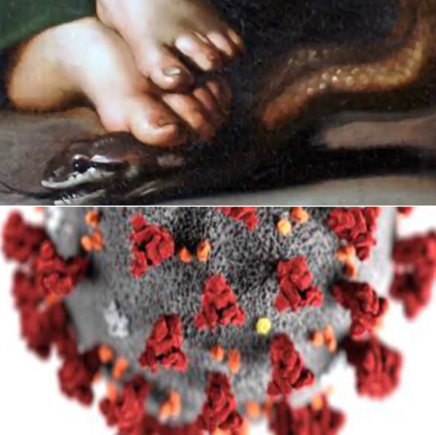
Red flags of the COVID-19 agenda
Fr. Jordi Rivero

Humanity has suffered greatly from COVID and government measures that were imposed with the assurance that they would stop the spread. We would like to trust, but the evidence of exploitation of the pandemic by powerful interests cannot be ignored.

The Church’s mission in a crisis is to stand courageously as a beacon of Christ’s hope, faith, and charity. Sadly, many in the Church have uncritically collaborated with the COVID agenda of forced vaccination, wrongful hospital protocols, lockdowns, and business closures. By doing so, they contradicted the official Church teaching:

Practical reason makes evident that vaccination is not, as a rule, a moral obligation and that, therefore, it must be voluntary. Congregation for the Doctrine of the Faith:

It is not the competence of the Church to evaluate the effectiveness of lockdowns and vaccines.

Evaluation [of the vaccines] is the responsibility of biomedical researchers and drug agencies. CDF

While serving in pro-life ministry, I saw how the government, the media, Planned Parenthood, and the drug companies colluded to perpetuate the abortion holocaust through massive disinformation campaigns about the unborn child and abortion. The well-known slogans “pro-choice” and “woman’s rights” aimed to make killing children socially acceptable.

Another example of the “disgraceful entanglement between regulators and the drug companies they oversee” is the opioid epidemic [here]. Doctors relied on the information of the drug companies, who assured them that their painkillers were not addictive even when they knew well that they were [here].

The drug industry profits from vaccines are astronomical, and they, too, have been produced unethically in the past, prompting the Pontificia Academia Pro Vita to warn in 2005:

There remains a moral duty to continue to fight and to employ every lawful means in order to make life difficult for the pharmaceutical industries, which act unscrupulously and unethically. ~Vatican PAL

As Catholics, we believe that God has endowed us with reason so that we can develop science, such as the marvelous advances in medicine, including some vaccines, that have saved so many lives. But we also believe that, in our fallen state, we can use God’s gifts to harm. We should not turn a blind eye to the exploitation of science. Drugs have become a lucrative and corrupt business in a culture that has forsaken God and lost respect for human life.

How is all this related to the measures against COVID? The pandemic has presented a golden opportunity for Big Pharma, the government, and the media to increase their control and power: Big Pharma produces the vaccine, the government mandates them, and the media runs the propaganda to sell the narrative [here]. The same players that are behind the COVID agenda are aggressively pushing abortion and “gender reassignment surgeries” for children [here], disregarding the authority of parents or the conscience of medical personnel.

The surgeon general of the state of Florida, Dr. Joseph Ladapo, wrote a book on how, during the COVID pandemic, public health decisions hurt more than they helped because they employed psychological strategies, such as using FEAR, to stimulate obedience/compliance. He writes: “I have a chapter about hydroxychloroquine, for example, and an unbiased look at the evidence there.” [video]

Three fundamental truths need to be kept in mind:

- Science is good. As Catholics, we believe that God gave us the ability to reason and use science for good. Advances in medicine have helped eradicate or alleviate many deceases. We should be grateful and support the good use of science and medicine.
- Science can be exploited and falsified. Science has been politicized. It is foolish to believe uncritically what authorities tell us in the name of science.
- Government has the authority to establish laws for the welfare of citizens, and Catholics should obey the law as long as they do not infringe on the rights of citizens.
- Individuals have inalienable rights. As society drifts away from Christian moral principles, more discernment is needed to protect ourselves from government infringement over our rights.

Making wise decisions based on the above truths is difficult but necessary. We cannot assume that government agencies are seeking to protect us.

Those of us who are not immunologists cannot judge the value of vaccines, but this does not mean that they should be forced on us. We have the right to seek a second opinion from scientists and doctors who have the same qualifications as those supporting the mandates. Many warn about the vaccine's dangers, lockdowns, and masks. Scientists like Ehud Qimron, head of the Department of Microbiology and Immunology at Tel Aviv University, wrote a strong letter exposing the failed pandemic policies. See also: Second Opinion, doctors’ testimonies on vaccine effects. A second opinion is most urgent given the corruption of those in authority who claim to represent science.

We need the alertness and prudence of a buyer listening to a sales pitch. I find many red flags in the official narrative and feel responsible for sharing them. These red flags are not just about the vaccines; they also expose the methods utilized by the government, the media, and the drug companies: coercion, intimidation, segregation of critics, derogatory characterizations, lies, and unwillingness to dialogue. Christians need to wake up and oppose these practices. Civil rights and human dignity are gifts from God and not government concessions.

It is understandable that many were fooled at the beginning of the pandemic into believing the government's narrative. They appealed to the moral principle of the common good. But it is no longer possible to ignore the truth without being morally culpable. Accepting our mistakes and correcting them is hard to do. One doctor that did tells us why [here].

Perseverance on a difficult but noble path is a virtue.
Stubbornness in the face of evidence that proves us wrong is a vice.

We have a God-given right to make our own decision regarding our health, especially when there are compelling reasons to be alarmed about the mandates. Government mandates are not dogmas. Laws that overreach the function of government are not morally binding. The official teaching of the Church is that vaccines cannot be mandatory [here]. Therefore, they are not a moral obligation. This warrants that the Church should respect those who, having examined the available information, have chosen to heed the warnings of numerous scientists who oppose the government's COVID agenda.

We are not contending against flesh and blood, but against the principalities, against the powers, against the world rulers of this present darkness" (Eph 6:12).

We can only succeed if we "take on the whole armor of God."

I encourage you to learn from the lesson of the COVID mandates because the government will continue to force its agenda in other ways. Pray, examine the arguments, and decide according to your conscience without pressure. Seek the truth, not the easy path, even when it takes you against the current. May the Holy Spirit—not fear—be your guide.

Whatever you decide, I urge you to love and respect your brothers and sisters who may have made a different decision. Vaccinated or not, we are all one in Christ. But the issue at hand is not just the vaccine. We cannot remain blind to the tyrannical measures of deception, coercion, and persecution.

Red Flags:
1 –Deception and Coercion
2 –Vaccine effectiveness vs. Adverse effects
3 –Prevention and Treatments are Forbidden
4 –Corruption
5 –Masks, lockdown, and vaccinating children
6 –Indiscriminate Vaccination

Red Flag #1: Deception and Coercion
I list deception and coercion together because they make up a two-pronged attack in Satan's strategy: If he can't deceive us and we resist by questioning or seeking alternatives to the official agenda, coercion follows. Already, the politics that began deceptive persuasion are employing the iron fist.

Objectives of deception:
- To sell the government's agenda by repeating lies until they are accepted as science.
- To discredit critics, calling them misinformed or conspiracy theorists.
- To deflect attention from reasonable objections and solutions.
- To block discussion
- To justify their tyrannical practice.
- To pressure dissenters into submission. – Forming a caste system where those who do not submit to mandates become second-class citizens without rights.

■ Violation of Patient's Fundamental Rights in order to Impose an Agenda. Woman Escapes COVID-19 Hospital Treatment Protocols, Says Others Not So Lucky [here]
■ Mass Formation Psychosis. How Mass Media Propaganda Fuels and Intensifies Mass Formation Psychosis. –Mattias Desmet, professor of psychology.
■ Censorship
No honest person can deny that the government colluded to censor experts that opposed the COVID agenda. If censorship is not fought, we will lose our freedom of speech.
- US government colludes with big tech to censor speech. Stablished the “Disinformation Governance Board” [here]
- “Tackle disinformation in real-time.” –BBC established the Trusted News Initiative (TNI), a concerted effort by Big Media to suppress all information that is not in accord with the official narrative. Partners include Facebook, Twitter, Reuters, and The Washington Post. “The truth is what those that are managing TNI say it is.” ~Dr. Malone
- Vast evidence of collusion between government officials and social media companies to censor high-level experts [here]
- CDC withholds data [here] / Government suppresses free speech [here]
- FDA refuses to make public the results of their own COVID-19 vaccine safety analyses [here]
- Many are fired for criticizing the dogmas of the State (COVID, abortion, LGTB agenda) [here], [here]. We are being indoctrinated so that we submit quietly.
- Intelligence agencies censor “anti-vaccine propaganda.”[here] (12/02/21)
- YouTube censors what contradicts the COVID-19 agenda. [here] I know this personally because YouTube has canceled some of our videos. Prime targets are scientists and doctors. Their views are declared “dangerous” and “irresponsible.” They are vilified and accused of misinforming; they risk losing their jobs, licenses, and grants. Their accounts on social media are canceled.
- Google and Amazon set up search algorithms to favor the COVID-19 official narrative and bury opposing views. Instead of protecting citizens, Big Gov. reinforces this practice. See Google’s ties with the U.S. gov.
- Twitter – Dr. Malone, a key scientist behind mRNA vaccines, is kicked off Twitter. [here].
- ‘Fact checkers’ pose as judges of truth to control information [here] [here] [here]

■ Condemnation, Coercion, Jailing dissenters
Many, even in the Church, accept and engage in the following behavior.
- Threats, defamation, and coercion. These are serious sins and are most dangerous coming from those in power.
- Government silences and demonizes parents who express concerns at school board meetings and anyone who disagrees with the COVID mandates. The Department of Homeland Security uses its “terrorist threat advisory” to warn of “the proliferation of false or misleading narratives.”
- Journalist fined and jailed for reporting. [here]
- 48% of Democratic voters favor fines or imprisonment for all who question the COVID-19 vaccine’s efficacy. [entire poll]
- President and media fomented division and fear with false claims such as that the nation is suffering from a “pandemic of the unvaccinated.”
- A Baylor professor and frequent MSNBC and CNN guest commented that it should be considered a hate crime to criticize Mr. Fauci.[here] It is OK, however, for those outlets to malign scientists who disagree with Mr. Fauci.
- President Biden:
  - “For the unvaccinated, you’re looking at a winter of severe illness and death for yourselves, your families, and the hospitals you may soon overwhelm.”
  - “All these people who have not been vaccinated, you have an obligation to yourselves, to your family, and, quite frankly — I know I’ll get criticized for this — to your country.” [here]
■ Disparaging critics by creating stereotypes
- For example, saying that “anti-vaxxers” believe there is a chip injected with the vaccines.

■ Misrepresentation of arguments [here]
■ Suppression of Medical Treatment
“For the first time in American history a president, governors, mayors, hospital administrators, and federal bureaucrats are determining medical treatments based not on accurate scientifically based or even experience-based information, but rather to force the acceptance of special forms of care and “prevention”… For the first time in history medical treatment, protocols are not being formulated based on the experience of the physicians treating the largest number of patients successfully, but rather individuals and bureaucracies that have never treated a single patient—including Anthony Fauci, Bill Gates, EcoHealth Alliance, the CDC, WHO, state public health officers and hospital administrators.
The media (TV, newspapers, magazines, etc.), medical societies, state medical boards, and the owners of social media have appointed themselves to be the sole source of information concerning this so-called “pandemic.” Websites have been removed, highly credentialed and experienced clinical doctors and scientific experts in the field of infectious diseases have been demonized, careers have been destroyed, and all dissenting information has been labeled “misinformation” and “dangerous lies,” even when sourced from top experts in the fields of virology, infectious diseases, pulmonary critical care, and epidemiology.” [Here]
■ The Myth of “A Broad Scientific Consensus”
The government and Big Media assure us that there is “a broad scientific consensus” on the imposed pandemic measures. They create such a consensus by setting themselves as the exclusive authorities. Dr. Anthony Fauci, director of the National Institute of Allergy and Infectious Diseases (NIAID), said on CBS’s Face the Nation: “It’s easy to criticize [me], but they are really criticizing science because I represent science.” This arrogance impedes the scientific process, which requires critical thinking, open discussion, and peer reviews. When critical input is excluded and vilified, we have an ideology pretending to be science. [here]

Despite significant risks, numerous renowned scientists and doctors oppose COVID-19-related mandates. See a partial list at the end of this article. More than 46,412 medical practitioners and 15,707 scientists signed the Barrington Declaration. Dr. Francis Collins, NIH director, and Dr. Fauci tried to discredit the signers of the declaration [here] secretly. This is the pattern also followed by the media: No matter how qualified their critics may be, they are censored and accused of being “science deniers,” “Conspiracy theorists,” “spreaders of misinformation,” “public threat,” and even “Nazis.” [video]

How scientists and doctors are silenced
- Credentials erased. For Example, Wikipedia deleted the credentials of Dr. Robert Malone, a pioneer in developing the mRNA vaccine, because he is outspoken about the dangers of the vaccine.
- Suspension of medical license [here]
“Physicians who speak out are being actively hunted via medical boards and the press. They are trying to delegitimize us and pick us off one by one… this is not a ‘conspiracy theory’ but a fact.” ~Dr. Malone
- Government is the biggest source of funds for medical and infectious disease research. [here] Scientists and the institutions that hire them are financially dependent on the government and the pharmaceutical industry. As a result, those who oppose the official narrative face being censored, slandered or losing their jobs or license.
- How doctors are silenced. [here] Doctors are afraid to speak out because they can lose their medical licenses if they challenge the mainstream narrative. (see: California Assembly Bill 2098)
- Hospitals have an enormous incentive. The U.S. government pays a 20% upcharge on the hospital bill when Remdesivir is used. Hospitals are paid for the use of ventilation and for reported COVID deaths.
- A doctor’s emotional testimony.
■ Lies and propaganda
- Lies perpetuated by the government. In October of 2022, against all the scientific evidence to the contrary, the governor of California continued to claim, “Throughout the pandemic, we’ve been guided by the science and data—moving quickly and strategically to save lives.”
- The noble function of journalism is disappearing as it becomes a tool of the state and of powerful interests.

- Crafting Messages for Vaccine Compliance. Making false statements to achieve vaccination by any means. Using guilt, anger, or shame. [here]
- Fomenting fear and anxiety to induce compliance [here]
- Who are the agents of “Misinformation”? Much of what was condemned as misinformation a few months ago is now universally recognized to be true: The vaccinated DO catch and spread COVID. Masks do NOT work. COVID-19 came from a lab, not a “wet market.”
- Big Pharma controls and censors the media through advertising money. –“Tapper (from CNN) has gone two years without asking Dr. Fauci a single tough question. He has covered up Fauci’s involvement with Wuhan, suppressed news of vaccine injuries, gaslighted the injured, and defended every official orthodoxy on masks, lockdowns, social distancing, vaccines, Remdesivir, Ivermectin, and hydroxychloroquine. He has never asked about the public health, mental health, and economic costs of lockdown, about the disproportionate burdens of Dr. Fauci’s policies on minorities, the working class, and the global poor. He has never asked Dr. Fauci to explain why countries and states that refused Dr. Fauci’s prescription have consistently experienced dramatically better health outcomes. ~ Robert F. Kennedy Jr., author of The Real Anthony Fauci: Bill Gates, Big Pharma, and the Global War on Democracy and Public Health [book]
- The mainstream media is subsidized by government payoffs and grants from Bill Gates and other oligarchs. They are creating a two-tier society based on submission to the ideology of the New World Order.
- Government/media collusion to discredit scientists who question Fauci. –Revealed by The National Institute of Health emails. [American Institute for Economic Research]
■ A Pandemic Exploited to Force Universal mRNA Vaccination
- Oct 2019: A panel discussion on how to force mRNA vaccination when people are not afraid enough of the flu virus. Dr. Fauci comes up with the solution: "we're going to address the problem in a disruptive way." Video of Milken Institute Health Summit, 1min 51sec
- To achieve their agenda, global leaders made vaccination the principal response to the COVID-19 pandemic. [here]

■ We were told:
- Vaccines will “Not be mandatory”
  - Biden: “I wouldn’t demand it (vaccines) to be mandatory” [video]
  - Mandatory vaccination went from a “conspiracy theory” to official policy.
- “If you are vaccinated, you are not going to get COVID” [here]
  - Vaccination was billed as the only way to return to normalcy.
  - Later: The CDC said: “there is a reduction of protection over time” [CDC director]. Then came the “booster shots,” every six months [here], which mean a 6 billion dollar annual profit for Big Pharma [here]. The implementation of booster shots without adequate data prompted the resignation of two senior FDA officials [here]. Still, as of Dec 20, 2021, some countries have cut the booster intervals to 3 months.[here]
- “Masks for 100 days”
  - President-elect Joe Biden (Dec. 2020) called for Americans to wear a mask for 100 days so that, combined with vaccines, deaths will “drop off the edge.”[here] “I don’t think masks have to be made mandatory nationwide.” [here]
  - “The vaccinated need not wear masks and can go back to a normal life.”
  - A year later, masks are still mandated, and there were more deaths in 2021 than in 2020.
- Definitions changed to control the narrative. Fauci says that the definition of “fully vaccinated” will change. “It’s going to be a matter of when not if.” The definition of “gain of function” also changed to evade responsibility for the origin of the virus. [here].
■ Herd immunity
Dr. Anthony Fauci claimed that when herd immunity is achieved, the disease will fade, and life will return to normal. Finally, he acknowledged that he had deliberately lied to get people vaccinated. Dr. Fauci:
When polls said only about half of all Americans would take a vaccine, I was saying herd immunity would take 70 to 75 percent ... Then, when newer surveys said 60 percent or more would take it, I thought, "I can nudge this up a bit," so I went to 80, 85... We really don’t know what the real number is. I think the real range is somewhere between 70 to 90 percent. But, I'm not going to say 90 percent [here].

As of Dec 17, 2021, 73% of the USA population has been vaccinated [here], and most of the rest had natural immunity from having acquired COVID. So, what happened to herd immunity?
“Herd immunity is not a possibility because it (virus) still infects vaccinated individuals” –Dr. Pollard is one of the lead researchers of the AstraZeneca vaccine. [here]

■ The cover-up of the origin of the virus
- Evidence points to the virus originating at the Wuhan lab, not at a wet market, as we were told. [here], here, here.
  - Then Dr. Fauci denied that the NIH funded gain of function research. [here]
  - Funding continued even after French intelligence warned the U.S. Dept. that they had grave concerns about China’s motivation for cutting back on agreed collaboration at the lab.
  - President Biden also lied on this subject.
  - Chinese virologist whistleblower speaks up despite threats to her life [here]
■ Violent repression
- Police deployed dogs and water cannons on demonstrators because it is illegal to have a gathering of more than two persons. ~Holland, Jan 2022 [here]
- FBI raid on journalist’s home, confiscation of documents. ~ U.S. [here]
- Raid on chemist’s home and mysterious death. I don’t know if Dr. Noack’s claims about the vaccine are valid; that is not the point here, but rather the use of violence against dissenters from the official narrative. Not even the “fact-checkers” deny that his home was raided. He died (supposedly of “natural death”) soon after. [here]
■ Vaccine passports
These passports, used as a tool to enforce vaccination policies, enable the government to violate civil rights guaranteed by natural law and the U.S. Constitution, such as travel, work, entrance to stores, and restaurants. They have also been proposed as a requirement to enter groceries stores and for medical treatment. Already millions of Americans have lost their jobs. These passports are already in use in several countries.
- Not long ago, it would have been considered a “conspiracy theory” to claim that such passports would exist.
- Vaccine passports open the door for the government to violate other civil rights. [here]

■ Forced “re-education,” a tool of tyrannies to deal with resistance
- Compulsory re-education for Penn State Employees who refuse vaccination. [here]

■ Concentration camps
Calling them by another name does not change the reality. Camps to detain persons with COVID were used in Australia [here]. The U.S. gov. also considered “green zones.” Official CDC site.

Red flag #2: Vaccine Effectiveness vs. Adverse Effects

COVID-19 is killing people, so why refuse the vaccine?
–Because before using any medication, a person should consider the following:
- Risks vs. benefits.
- Evaluate the alternatives to protect others and self (see red flag #3)
- Decide without coercion. Since it is known that vaccination does NOT stop the spread, there is no reason for the government to force vaccination.

■ Effectiveness: Do vaccines stop the spread of the virus?
- Even with booster shots, the vaccinated get infected and spread the virus. The Lancet Journal
- Those infected, whether vaccinated or unvaccinated, carry the same viral load. [here]
- This was known from the beginning. U.S. Surgeon General Jerome Adams, Good Morning America, Dec 14, 2020: “They (vaccines) were tested with an outcome of severe disease — not preventing infection.”
- “Data Show the COVID Jabs Have No Impact on Infection Rates” [here]
Examples
- Large COVID-19 outbreaks in 97% vaccinated institutions, Dec 2021 [here]
- The majority of airline employees infected with Omicron are vaxxed, Dec 2021 [here]
- July of 2021– 469 cases of COVID-19 were identified in a town in Massachusetts; 74% of them were fully vaccinated persons. Of the five hospitalized, four were fully vaccinated. The CDC, instead of recognizing vaccine failure, concluded that masks are still required [here].
- Fully vaccinated cruise ships have repeatedly tested positive for the virus. [here] [here] [here]
- U.S. warship has COVID outbreak among fully vaccinated crew [here]
- The Omicron variant was first detected in Botswana in four fully vaccinated persons. [here] The first U.S. Omicron patient was fully vaccinated [here]. The first two cases detected in Australia were also fully vaccinated. [here].

■ Do vaccines reduce the risk of severe illness and death?
Since vaccines do not stop the spread, they are only justified if they lower the risk of serious illness. In that case, it should be the right of each individual to choose the type of prevention and treatment, as discussed in red flag #3. But there is more:
- People have been misled to believe they are in great danger of death from COVID-19. Facts: “In the pre-vaccination era, the median infection fatality rate of COVID-19 was estimated to be 0.035% for people aged 0-59 years people and 0.095% for those aged 0-69 years.” [here]
- Manufacturers misled us by using a relative risk reduction in preventing the disease (67% and 95%) instead of the absolute risk reduction, which is 0.7% and 1.3%. See excellent explanation: “COVID-19 vaccines do more harm than good” [video by Canadian doctors].
- Countries with high vaccination rates are at the top of the list of COVID death rates –See charts at the bottom of this article.
- The data from the official agencies are contradictory. While some countries report that most COVID hospitalizations and deaths are among the unvaccinated, others report the opposite:
  - Australia: Vaccinated in hospitals with COVID surpass the unvaccinated [here]
  - U.K.: Vaccinated make up 80% of COVID deaths (official U.K. Health source linked here)
  - Israel: “Nearly 60% of hospitalized COVID patients are fully vaccinated” [here]
  - British Columbia: Approx. half of COVID deaths (Oct. 2021) were among the fully vaccinated [here]. Hospitalization in Ontario: 70% vaccinated [here]
- The government used deceptive practices to force compliance. Hospitals were instructed and incentivized to use Remdesivir and mechanical ventilation and to mark any patient who died after a positive COVID test as a COVID death, even when they died from other causes. PCR tests are unreliable, producing inordinate amounts of false positives. More on the government’s deceptive practices.
- COVID deaths in 2021 surpassed those of 2020 when there were no vaccines. [here]
- Researcher: ‘We Made a Big Mistake’ on COVID-19 Vaccine [here]
- Dr. Aseem Malhotra, who promoted the COVID-19 vaccine on TV, calls for its immediate suspension writing in the peer-reviewed Journal of Insulin Resistance [here]
- “Vaccine antibodies now offer zero protection, while the spike protein is ubiquitous and lurks in tissues, causing reactions that are serious.” –Dr. Andrea Zambrano, Bioimmunology specialist, Jan. 13, 2023. [here]

■ COVID Vaccine Adverse Effects
- Vaccine adverse effects reports reached 1,119,061, including 23,990 deaths by Feb 11, 2022 – VAERS (official database) (Current # here). This is despite significant under-reporting [here] [here] [here]and censorship.
- CDC refused to release V-SAFE data until forced. The results continue to be ignored.

There is much more:
- Based on official data U.S. and U.K., the risk of COVID Vaccine-Induced Fatality is Equal to or Greater than the Risk of a COVID death for all Age Groups Under 80 Years Old as of 6 February 2022. [Here]
- Florida Surgeon General Warns mRNA Vaccines Are Killing Men; Top Medical Journal Skews Vaccine Data [here]
- Total mortality in the USA in 2021 was up 40% from previous years among working-age, most not COVID related. [here] It begs the question: why? Since most of them did not die from COVID, what else was different in 2021, if not the vaccine?
  - “A one-in-200-year catastrophe would be a 10% increase over pre-pandemic, so 40% is just unheard of. (In addition to deaths), disabilities are up.” ~insurance CEO.
- The higher the vaccination rate of a country, the more excess mortality. [here]
  - They are dying of causes (heart attacks, etc.) that public health agencies claim are unrelated to the COVID vaccine [here] But why more of these deaths than before?
- Thousands of healthy people are dying unexpectedly.
  - Athletes —There is a 5-fold increase in sudden cardiac and unexplained deaths among FIFA athletes in 2021. [here] Similar phenomena are occurring in all sports despite a 90 to 100% vaccination among athletes. [here] Coincidence? See a list of athletes affected [also here] [here]. Most social media censor this documentation.
  - 44% increase in teen deaths after vaccine rollout in U.K. [here]
  - Doctors’ data for the military in 2021: Nearly 300% increase in cancer diagnoses, more than 1,000% increase in neurological issues over the five-year average, 269% increase in myocardial infarction, 291% increase in Bell’s palsy, 156% increase in congenital malformations of military members’ children, 471% increase in female infertility, 300% increase in miscarriages during the first ten months of 2021 over the five-year average, and 467% increase in pulmonary embolisms. [here]
    - Dr. Merritt, a U.S. Navy physician, adds, "With the vaccine program, we've ostensibly killed more of our young active-duty people than COVID did"[here].
- American Heart Association’s warning: “mRNA COVID Vaccines Dramatically Increase Endothelial Inflammatory Markers and ACS” [here] (but not even the AHA escapes media censorship! [here])
- COVID-19 Vaccines Increase Risk of Cardiac Arrest in Young People by 25 Percent [here]
- Vaccine-Induced Thrombotic Thrombocytopenia [here]
- Funeral directors speak
- Embalmers are finding novel clotting in over 50% of bodies since 2021 [here] –Again, no agency is investigating. It is dismissed by the government and media.
- Cancers coming back with a vengeance is very common after the COVID vax [here]
- More vaccine effects: shingles and Bell’s Palsy (point to dangerous immunosuppression, with short and long-term implications, including cancer). / Myocarditis / Neurodegenerative Disease (Read the conclusion) / Immune thrombotic thrombocytopenia (VITT) / Cerebral hemorrhage
- Pregnancy and vaccines Stillbirths / Researchers call for a halt on the COVID-19 vaccine for pregnant women.
- Scientists in the U.K. call to stop COVID-19 vaccines as “not safe for human use.” [here]
- A study showed that SARS-CoV-2 RNA could be reverse-transcribed and integrated into the genome of human cells. [here]
- Johnson & Johnson Vaccine elevates risks [here]
- A universal vaccination policy could backfire. –Dr. Robert Malone, inventor of the mRNA vaccine / Dr. Peter McCullough.
- Can we trust the CDC when they are not revealing the known risks on their side effects page? (8/31/21) It only mentions mild reactions and does not mention: Death, disability, miscarriage, heart attacks, paralysis, blindness, Bell’s Palsy, Parkinson-like symptoms, re-activation of shingles, blood clots, etc. But all of the above is occurring.
- 8 Ways Spike Protein Harms the Body and How to Remove It
- COVID-19 Vaccination Reactivates Highly Contagious Virus [here]
- Physicians speak out
  - Physicians go public with their stories in hopes that more doctors and the federal government will start taking vaccine safety seriously. These physicians and their patients all previously supported the Covid-19 vaccine. [Catholic World Report]
  - Dr. Peter McCullough, cardiologist, Senior Professor of Internal Medicine at the Texas A&M University Health Sciences Center, has called for a halt to vaccinating 30-year-olds due to “no clinical benefit” and safety concerns. [here]
  - Open letter from Doctors and Scientists regarding COVID-19 vaccine safety.
  - Dr. Malone’s page on the vaccine’s adverse effects [here]
  - Doctors are concerned that the mRNA vaccine does not remain at the injection site but instead appears to spread and concentrate in organs, including the ovaries and spleen.
  - Vaccine corruption and danger. Judy Mikovits PhD
  - COVID-19 vaccine concerns Sharyl Attkisson
- Testimonies of severe adverse reactions you will not see on mainstream media:
  - NoMoreSilence.world/ VaxTestimonies.org (Israel)/ VaccineVictim.blogspot.com /Baby/ military

Red flag #3: Prevention and Treatments Forbidden/Ignored

A vital factor in discerning COVID treatment or vaccination is evaluating the options, but the government has blocked this option. All forms of prevention except the vaccine are forbidden [here], as well as all treatment protocols for COVID patients until they are sick enough to be admitted to a hospital. Then, some hospitals practice a form of medical kidnapping, where COVID patients have no right to choose their treatment (even with their doctor’s prescription), nor can they reject the treatment that is forced on them. Family members are often forbidden to visit or intervene.

■ Most people recover from COVID. Why is it that some don’t?
- 99.99% of COVID-19 patients survive with an early treatment used by a doctor’s organization that has treated over 150,000 COVID-19 patients [here]. Yet it is ignored by gov. agencies.
- People are dying of COVID-19 due to inadequate treatment [here]
- 95% of those who die of COVID have other comorbidities and underlying conditions that contributed to the death. [here] Hypertension is the most common of these, and it is caused by the disruption of lives by the mandates and fear. [here]
- Those hospitalized or who die of COVID but not because of COVID are counted as “COVID patients.” Ex.: Someone who has COVID, falls from a roof, and is hospitalized, is counted as a COVID patient in the stats. [here]
- Vitamin D insufficiency may account for almost nine of ten COVID-19 Deaths.
- Having a good diet, adequate vitamins, and weight allow the body to fight the virus and overcome it if you get it. See Pandemic Contributors We Don’ Talk About [here]
- There is no attention to the severe consequences of immune system degradation from multiple toxic stressors (chemical, physical, biological, and psychosocial stressors) [here]. Much could be done to reduce many of these. Instead, the problem is exacerbated by mandates leading to stress, suicide, mental illness, and social breakdown.

■ Prevention and Treatment Protocols
Prevention and treatment protocols remain forbidden even though they were developed by infectious disease specialists and have been used successfully with thousands of patients. Download this guide to COVID treatment
- Similar protocols: Dr. Zelenko [here] or Canadian Covid Care Alliance [here] / FLCCC
- “The virus that causes COVID-19 is very, very easily treatable if early treatment is done with off-label drugs,” ~Dr. Syed Haider. He has treated more than 4,000 COVID-19-positive patients so far during the pandemic. Just five ended up going to a hospital, and none died. His preferred treatments include many off-label medications along with vitamins and supplements. [here]

■ The essentials of the protocols:
- Vitamin D: 70 to 80 % of Americans are Vit. D deficient and are therefore more vulnerable to COVID. –Dr. Ryan Cole Vit. D deficiency is linked to COVID deaths; See also:[here] [here] [here].
- Zink: Known to be an anti-viral mineral. It impairs viral replication.
- Ivermectin information: The effectiveness of ivermectin spreads thanks to courageous doctors and the testimony of people who have used it.
  - Dr. Joseph Varon, MD, was frequently interviewed for his dramatic success using the MATH+protocol, including ivermectin, with COVID-19 patients. This is a protocol that CDC and WHO oppose. When asked: “Have any reporters told you they were banned from covering these COVID treatments?” His response: “I was told that not once but multiple times.” Dr. Varon says that Big Tech also censors him. He concludes: “I totally believe what we are dealing with here are economic interests.” Yet he perseveres: “There is no reason for people to die. We have options for patients. We just need to make those options available.” [here]
  - Florida Surgeon General supports COVID prevention strategy [here]
  - According to pro-vax Dr. Pierre Kory MD, Ivermectin is rejected because it is cheap and presents a threat to the pharmaceutical industry's profits.
- Nebulized Hydrogen Peroxide. A simple home treatment using food grade Hydrogen Peroxide diluted to a 0.1% concentration [here] [here]

Starting Peroxide  Concentration | Hydrogen Peroxide | + Normal Saline | = Ending Peroxide Concentration
3 % | ¼ tsp | + 7 ¼ tsp | =0.1%
12 % | ¼ tsp | +5 ounces | =0.1%
36% | ¼ tsp | +15 ounces | =0.1%

  - Also, Hydrogen Peroxide 1% diluted in a neti pot to rinse nose and mouth
- Quercetin [here]
- Nasal saline irrigation [here]
■ The war against COVID-19 prevention and treatments
The federal government, pharmaceutical, and insurance companies dictate what care hospital administrators can offer. They ban information and the use of treatments, such as ivermectin. They can’t (yet) forbid other essentials such as Vitamin D and Zinc; instead, they withhold information about their role in preventing COVID-19.
- Government agencies claim that there are not enough studies of the treatments described above and that their effectiveness is “largely observational” or “anecdotal.” But the truth is that:
  - Ivermectin has been shown effective in 31 randomized controlled trials[here] and is known to be safe.
  - Ivermectin efficiency confirmed by top doctors [here]
  - In Mexico, the IMSS (health agency) found a 70-80% reduction in hospitalizations in the group using ivermectin. Similar studies were done in India and other countries.
  - PubMed.gov, August 2021: “Since March 2020, when IVM was first used against a new global scourge, COVID-19, more than 20 randomized clinical trials (RCTs) have tracked such inpatient and outpatient treatments. Six of seven meta-analyses of IVM treatment RCTs reporting in 2021 found notable reductions in COVID-19 fatalities, with a mean 31% relative risk of mortality vs. controls… During mass IVM treatments in Peru, excess deaths fell by a mean of 74% over 30 days in the ten states with the most extensive treatments. Reductions in deaths correlated with the extent of IVM distributions in all 25 states with p < 0.002.”
- Doctors and scientists are silenced when they present evidence that what is killing people is the wrong protocol perpetuated by the system.
- Doctor fired for trying to treat patients with ivermectin [here]
- People with COVID are told to stay home until they are sick enough to need hospitalization. In the meantime, they are not informed about the protocols mentioned above. I have confirmed this with several testimonies.
  - Testimony of a nurse about hospitals blocking early treatment and consequences [here]
- The sale of Ivermectin for COVID is forbidden in the USA, even with a doctor’s prescription.
  - The government’s pretext is that people could overdose on ivermectin. (People can “overdose” with any substance, even aspirin).
- Hospitals are not allowed to use ivermectin. Patients and families have lost the right to seek alternative treatments, no matter if the hospital declares that there is nothing they can do for the patient or if the patient has a doctor’s prescription for ivermectin. The family is forced to seek a court order, which often is not granted. [here] [here] [here]
- The inexplicable suppression of Hydroxychloroquine, Ivermectin, and other COVID-19 treatments [here]
- The media supports government policy by discrediting ivermectin. [here]
- Could it be that pharma lobbies want no competition for the vaccine and the anti-viral pills that Merk and Pfizer are developing?

How About Academic Journals?
    - Few scientists and doctors are independent. They work for agencies or universities that, in turn, depend on government and pharma money.
    - Example: Hydroxychloroquine is an effective treatment that lowers the death rate of COVID patients, but it is inexpensive and ruins the interests of Big Pharma. The Lancet and The New England Journal of Medicine, both premier medical science journals, published fraudulent studies that discredited the use and had to retract them.

Red flag #4: Corruption
■ The collusion of Big Gov., Big Media, Big Pharma, and other opportunists
- A lead scientist exposes how the silencing of scientific debate today is reminiscent of China’s manipulation of science for political ends. [here]
- Precedents:
  - “The Cost of Capture: How the Pharmaceutical Industry has Corrupted Policy Makers and Harmed Patients” ~by the Roosevelt Institute, 2019 (one year before the pandemic).
  - The government’s historical collusion with Big Pharma: The case of Dr. Burzynski
- Regulatory agencies are corrupted by collusion with Big Pharma
  - 45% of the FDA budget comes from drug companies seeking approval for drugs or devices. [here]
- Regulatory agencies pay off scientists who support their narrative. [here]
- Gov. incentives impact COVID treatments [here], including hospitalizations attributed to COVID-19 when there is another primary cause. [here] [testimony]
- Why sick people are profitable. [here]
- FDA says it needs 75 years to fully release Pfizer COVID vaccine data [here]
- CDC hides COVID-19 data because it could be “misinterpreted.” [here] It also manipulates data [here] [here].
- Mr. Fauci
  - The Fauci – Bill Gates multi-billion-dollar vaccine empire [here]
  - Who is in charge of assuring that Dr. Fauci’s practices are ethical? His wife! She is the head of the NIH’s Bio-Ethics Department [here]
  - The government keeps Dr. Anthony Fauci as chief medical adviser, directing the COVID-19 policy after he lied under oath about his participation in the gain of function research and the NIH funding the Wuhan lab [here], ,;; ,,
- The World Health Organization (WHO) dictates COVID policies for most of the world. Its main financial contributor and partner in global health initiatives is Mr. Gates: The Global Alliance for Vaccines and Immunization (GAVI).
  - Mr. Gates’ foundation was expelled from India for exploiting vulnerable persons with vaccine programs. Mr. Gates is an outspoken supporter of population control and vaccines.
- A European parliamentarian raises concerns about governments using COVID-19 as a pretext to pass abusive laws. [here] [SP video]
- U.S. Senator Ron Johnson exposes the exploitation of COVID: [video] Dec 8, 2021

■ Corrupt Drug Manufacturers
- Vaccine clinical trial corruption: Maddie de Garay suffered a seizure and became wheelchair-bound after participating in the Pfizer COVID vaccine trial for children aged 12-15. Rather than acknowledge the event as a consequence of the vaccine, Pfizer removed her from the trial. [here]
  - Researcher blows the whistle on data integrity issues in Pfizer’s vaccine trials [here]
  - Pfizer has a history of manipulating data [here]
- Pfizer: a history of crimes.
  - $2.3 Billion plea deal with federal prosecutors for false promotion of medicines.
  - $430 Million fine for bribing doctors
  - $142.1 Million for Racketeering fraud in its marketing of the drug.
  - Was sued in a U.S. federal court for using Nigerian children as human guinea pigs without the parents’ consent. Pfizer paid $75 Million to settle in a Nigerian court. The company paid an additional undisclosed amount in the U.S. to settle charges here. Pfizer had violated international law, including the Nuremberg Convention established after WWII, due to Nazi experiments on unwilling prisoners.
- Drug manufacturers are making an outrageous profit of billions with the vaccine and are seeking patents to hold exclusive rights and perpetuate vaccination [here].
- Vaccine manufacturers are exempt from liability for adverse effects, and the government ignores the injured. [here]

Red flag #5: Masks, lockdown, and vaccinating children
■ Masks
- “An objective and dispassionate review of the medical and scientific literature surrounding mask-wearing reveals that masks are ineffective for preventing infection from COVID-19 or other viruses. Masks are also ineffective in preventing the transmission of COVID-19 or other viruses to others. This is because the tiny virus micro-particles are so much smaller than the mask pore openings. It is akin to the oft-cited analogy of putting up a chain link fence in the vain hopes of keeping out mosquitos.
Indeed, ineffective masks have been found to have measurably harmful effects, such as increased incidents of life-threatening bacterial pneumonia, decreased oxygen levels in the brains of mask-wearers, and speech deficits in children. Masks are also unsanitary and function as bacteria collectors.” Read entire brief
- Some argue that masks are for extra safety and can do no harm. But they do harm; that is why OSHA has regulated face masks in the workplace for years.
- Why doesn’t the CDC compare places that require masks to places that don’t or compare cases before and after mandates went into effect? Instead, they use a deceptive method of analysis to justify their mandates.
- The media persistently criticized Sweden in 2020 for not mandating lockdowns and masks. Now, Big Media is silent about Sweden. Why? Because Sweden’s strategy is working. As of Sept 15, 2021, their per capita death rate due to COVID-19 is below the USA, Italy, Spain, United Kingdom, France, and a host of other countries that mandate masks and lockdowns. [here]
- Imposing masks and lockdowns on children is particularly harmful, and mandating them does not follow the science. [here] [here] [See Mark Mallet]
- From the first wave in the spring of 2020, Sweden was the only Western country that did not close down all the schools, and they did not mandate masks or social distancing. Among the 1.8 million children in Sweden during this first wave, there were zero deaths from COVID. [here]
- “A child’s current chance of death from Covid-19 in America is lower than their chance of dying from a lightning strike or car accident.” In addition, masks cause severe psychological trauma. [here]
- But the imposition of masks continues: American Academy of Pediatrics, which depends on gov. money, endorsed the CDC’s recommendation for masking. They contradicted years of research and their own information and took it down from their website as “part of a website migration.” This is an example of how data is manipulated to promote the narrative.
■ Lockdowns
- Those who warned about coming lockdowns were ridiculed as “conspiracy theorists,” yet they are accepted as normal. Lockdowns in some places are similar to house arrests. [here]
- “While lockdowns have had little to no public health effects, they have imposed enormous economic and social costs.” –Meta-analysis [here]
- Lockdowns have increased illness and mortality [here].
- The Great Barrington Declaration calls for a stop to lockdowns
- “We fail to find that SIP policy (lockdowns) saved lives. On the contrary, we find a positive association between SIP policies and excess deaths. We find that following the implementation of SIP policies, excess mortality increases.” [here]
- There is no relationship between lockdowns and virus control based on studies. [here]
- Five times more children committed suicide than died of COVID-19 during lockdown so far: U.K. Study
- Expert statement on lockdowns [doctors4covidethics]
- Researchers at Brown University found that mean I.Q. scores of young children born during the pandemic have tumbled by as much as 22 points. Verbal, motor and cognitive performance have all suffered due to the lockdowns. “Children born over the past year of lockdowns – at a time when the government has prevented babies from seeing elderly relatives and other extended family members, from socializing at parks or with the children of their parent’s friends, and from studying the expressions on the faces – have significantly reduced verbal, motor and overall cognitive performance compared to children born before, according to a new U.S. study. Tests on early learning, verbal development, and non-verbal development all produced results that were far behind those from the years preceding the lockdowns.”–Paul J. Watson [here]
- What happens during lockdowns (YouTube) [here]
■ Asymptomatic Transmission
- This is the reason for fear of contagion from persons without symptoms. It is used to validate lockdowns and distancing for all. But on Jun 7, 2021, Dr. Maria Van Kerkhove, head of the WHO’s emerging diseases and zoonosis unit, told a press conference that from the known research, the asymptomatic spread was “very rare.” “From the data we have, it still seems to be rare that an asymptomatic person actually transmits onward to a secondary individual.”[here] [here] Confirmed by Dr. Peter McCullough, Karina Acevedo W.[Español], Dr. Mike Yeadon.

■ Vaccinating Children [here]
- What parents need to know regarding vaccines for children [Dr. Malone]
- Scientists have come together to inform and seek the protection of children against the vaccine [TheUnityProject].
- Doctors petition to halt vaccines for children, pregnant women, and young adults [CanadianCovidCareAlliance.org]
- Fully vaccinated children ages 5 to 17 run a greater risk of hospitalization than those not vaccinated. Vaccinated children risk a severe illness called myocarditis. In addition, the vaccinated have unknown future consequences.
- Children under 18 recovery from COVID: 99.995% [here].
- The assessment reported by Public Health England, Sept 3, 2021: “The health benefits from vaccination are . . . considered too small to support universal vaccination of healthy 12 to 15 year old at this time. For the vast majority of children, SARS-CoV-2 infection … will resolve without treatment. Of the very few children aged 12 to 15 years who require hospitalization, most have underlying health conditions. There is evidence of an association between mRNA COVID-19 vaccines and myocarditis . . . The medium- to long-term effects are unknown, and long-term follow-up is being conducted.” [here]
- “I cannot imagine how mass vaccination of our youngsters and children will not lead to an even more disastrous outcome than all the scientifically irrational and unjustifiable vaccination efforts. …It cannot be that highly knowledgeable vaccinologists don’t understand this clear-cut message. I can only shout at all of them, no matter their international reputation, the number of awards and recognitions they’ve gotten, the number of books they’ve written or high-ranked papers they’ve published in peer-reviewed journals: SHAME ON YOU FOR NOT STANDING UP!” [article] ~G.Vanden Bossche, DVM, PhD, Oct. 2021.
- Why are they vaccinating children against COVID-19? (technical report)
- Still, Dr. Fauci thinks that vaccinating children is “a good idea” [here]

Red flag #6: Indiscriminate Vaccination

Forced vaccination violates a person’s right to decide; it disregards medical conditions and adverse effects. In some countries, vaccines are handed out like candy, even at nightclubs [here]

■ Natural Immunity
Everyone who had COVID (over 100 million Americans) has acquired natural immunity 13X stronger than Pfizer COVID shots. [Israeli study] Yet the government allows them no accommodation from the vaccine mandates. Vaccination has no benefit for them, only risks [here] [here]. They have 2X or 3X more risk of adverse events [Dr. McCullough]. Fauci has no answer.
- One hundred forty research studies attest to the superior strength and durability of natural immunity to Covid-19. [here]
- Natural immunity is more protective over time than vaccines. [here]
- Persons with natural immunity are at very low risk of re-infection severe disease [here].
- Dr. Marty Makary, professor at Johns Hopkins University School of Medicine, “mandating vaccines for ‘every living, walking American’ is, as of now, not well-supported by science.”

■ No Informed Consent.
A patient must be informed about possible adverse effects before dispensing any medicine. Informed consent cannot be given when side effects are hidden or when the injection is forced.

■ Conclusion
When there are radically divergent views from the experts, each person should have the right to decide how best to protect their health and the health of those around them. Respect the opinions of others. Do not allow the enemy to use a virus to bring division!

Babel
Our society is building a tower, as did the citizens of Babel, aspiring to reach heaven using their science and technology while ignoring God. But confusion is now leading to chaos, and the tower is falling apart. We cannot understand or trust each other because the conversation is deceitful. Decisions are made based on ideologies and the interests of the powerful, not on justice and the common good. We blame the pandemic, but the real culprits are the viruses of pride and avarice.

The Pharaoh
Plague after plague, Pharaoh obstinately relied on his gods and magicians. His pride did not allow him to accept that God was speaking through Moses. God can use COVID as an opportunity for us to repent and turn to Him. How many plagues will be needed until we let God’s will be done? Science and technology are gifts from God and must be used under His guidance.

The words of Benedict XVI are a light on the challenges we must face:
Dear friends, may no adversity paralyze you. Be afraid neither of the world, nor of the future, nor of your weakness. The Lord has allowed you to live in this moment of history so that, by your faith, His name continues to resound throughout the world.
Our Lord Jesus is with us always, in every decision, in each cross. He tells us:
Suffer all with me; we are no longer to but one, in my sacrifice of love.

■ Charts: Vaccination rate & COVID-19 deaths
Both charts cover the same seven countries and the same time period, Dec 2020 to Jan 2022. Check for yourself: Source: official data by Our World in Data. https://ourworldindata.org

Chart 1– Population % fully vaccinated
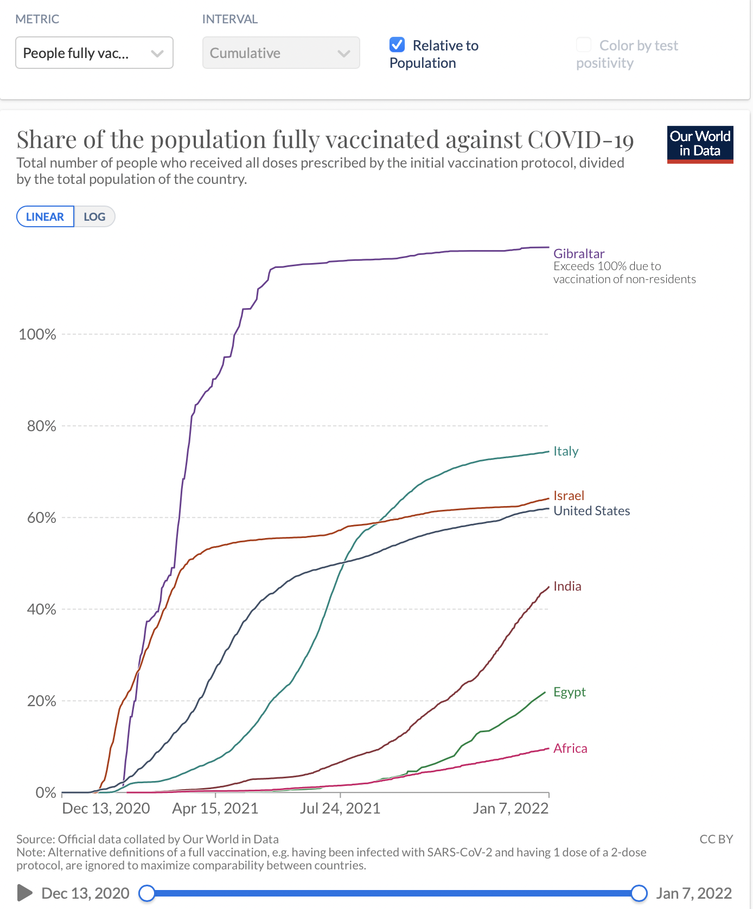

Chart 2– Confirmed COVID deaths / million
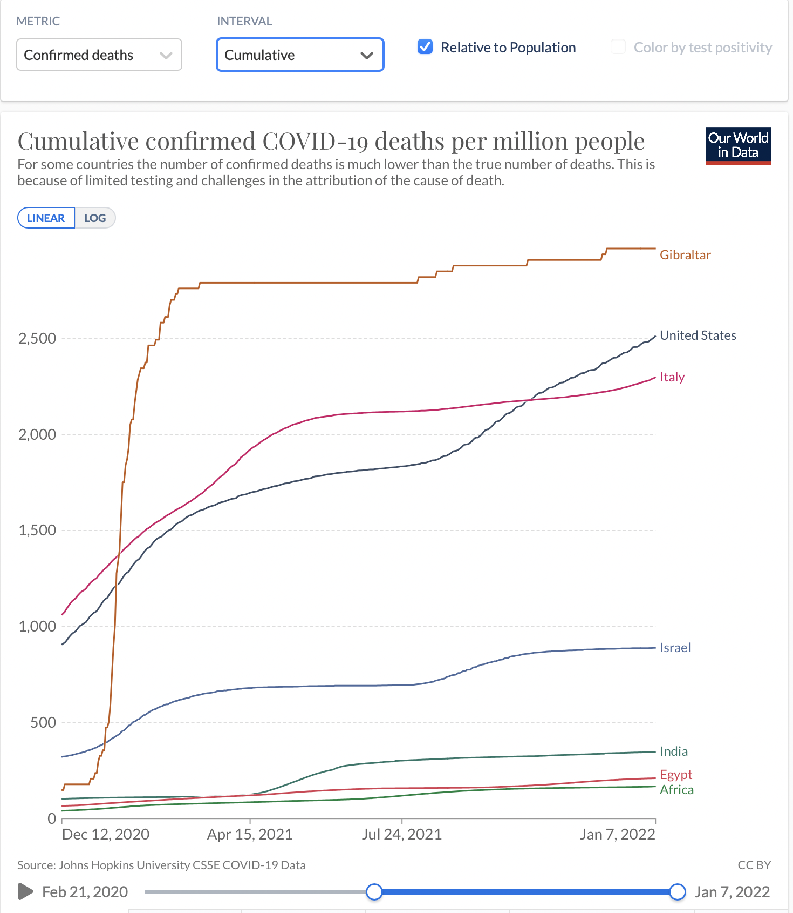

■ A sample of Scientists and doctors opposed to the COVID-19 vaccine mandates (There are thousands):
- Dr. Karina Acevedo W. –Doctorate in molecular ecology Español, Español, Español
- Dr. Sucharit Bhakdi, Professor emeritus head of the Institute for Medical Microbiology and Hygiene at the Johannes-Gutenberg-Universität in Mainz, Germany; Aronson Prize recipient for microbiology and immunology; German microbiologist; Has published over three hundred articles in the fields of immunology, bacteriology, virology, and parasitology.
- Dr. Dolores Cahill, Ph.D. received her doctorate in immunology from Dublin City University in 1994; Professor at the University College in Ireland; She was a Member of Ireland’s Advisory Science Council (2005-2014); a European Commission Seconded National Expert (2013-2014) and an EC expert for over ten years.
- Dr. Roger Hodkinson MA, MB, FRCPC, FCAP Ex-head of Alberta college of physicians and surgeons; Medical specialist in pathology and virology; Currently Chairman of a medical biotechnology company in North Carolina that produces COVID-19 tests. Medical expert in court.
  - Dr. Charles Hoffe, MD, Observed a high rate of severe side effects in his patients developing post-vaccination, including anaphylactic shock and neurological conditions. The agency accused him of ‘vaccine hesitancy‘ and informed him that he would be reported to the B.C. College of Physicians and Surgeons. He chose to risk his career to speak the truth, source
- Dr. John Ioannidis, MD, DSc, is a Professor of Medicine, Epidemiology, and Population Health, co-Director of the Meta-Research Innovation Center at Stanford (METRICS), and one of the most-cited scientists in scientific literature.
- Dr. John Lee, Ph.D., is a pathologist and former clinical professor of pathology at Hull York Medical School and is a Consultant Histopathologist at Rotherham NHS Foundation Trust.
- Dr. James Lyon-Weiler, Ph.D., Senior Research Scientist, University of Pittsburgh
  - Dr. Marty Makary, professor at Johns Hopkins University School of Medicine.
  - Dr. Robert Malone, Ph.D. Virologist pioneer in the invention of the mRNA Vaccine.
  - Dr. Mathew Memoli, Senior NIH doctor [here]
- Dr. Peter McCullough, MD, MPH. Professor of Medicine, Texas A & M College of Medicine, Board Certified Internist and Cardiologist, President of Cardiorenal Society of America. One of the most cited MDs globally in the National Library of Medicine on medical treatments, including for COVID-19, and has served on committees to investigate vaccine injuries. He has been censored, and his videos removed from YouTube. Here, Here, Español, Español
- Dr. Jim Meehan, MD, former editor of two medical journals.
- Dr. Lee Merrit, MD, former President of the American Association of Physicians and Surgeons
  - Judy Mikovits, Ph.D. Virologist.
  - Luc Montagnier, Nobel prize winner, virologist
- Dr. Christine Northrup, MD. Expert on women’s health issues and a former guest on numerous television shows.
  - Dr. Alan B. Moy, MD. CEO of Cellular Engineering Technologies, a biotech company that manufactures human stem cells (not fetal). He was banned from Facebook and hidden by Google. Part I. Part II He is developing an alternate vaccine. here
- Dr. Meryl Nass, MD. [here]
- Dr. Denis Raincourt, Ph.D., Researcher and former full Professor of Physics at Hull University in Ottawa, Canada
- Dr. Harvey Risch, Professor of epidemiology at Yale. [COVID Taboos]
- Dr. Beda Stadler, Ph.D. One of the top immunologists in the world.
  - Dr. Geert Vanden Bossche. Ph.D. virology. Made an urgent call to stop vaccination.
  - Dr. Mike Yeadon, Ph.D. Former Chief Science Officer and V.P. at Pfizer for 16 years.
  - Dr. Vladimir Zelenko, MD Among his COVID patients have been several presidents of nations. Eng-SP, Español
Doctor organizations opposed to COVID-19 vaccine mandates
    - Americas Frontline Doctors.
    - Association of American Physicians and Doctors
    - Doctors for Covid Ethics
    - Concerned Doctors
    - Canadian Covid Care Alliance
- Physicians for Informed Consent. Links to States network.
  - Doctors’ resistance to COVID [here]
  - Hospital workers choose not to get the vaccine because the risks outweigh the benefits. California, New York; some quit or are fired, and others submit to save their jobs [here].
  - Fifty-seven scientists and doctors ask for a stop to COVID vaccinations [here]
  - Doctor’s comments about adverse reactions to the vaccine. [here]

Resources
- Defense against mandatory COVID vaccines [here] [here]
- Slide presentation explaining vaccine essentials, questions, and answers [here]
- Healing COVID-19 long-haul effects [here]
- Healing vaccine effects EarlyCovidCare.org / Healing after vaccine / FLCCC
- Reviews of pandemic issues
- Dr. Peter McCullough
- PlandemicSeries.com.
- What happened? Video Dr. Jay Bhattacharya on 19 Months of COVID
- 18 reasons I won’t be getting a COVID vaccine
- Some questions and answers Christian Elliot, Oct 29, 2021
- Incriminating evidence –Steve Kirsch
- Mark Mallet. Top 10 pandemic lies, “wait-a-minute.”
- Summary of deception, coercion & obstruction of treatment in the COVID-19 pandemic

Webpages –Mainstream media censors critical information about COVID and the mandates. Thankfully there are alternative websites still available.
- Truth for Health TruthforHealth.org
- National Library of Medicine Pubmed.ncbi.nlm.nih.gov
- Real Science >>
- National Vaccine Information Center
- The Epoch Times. Vaccine Questions Pandemic Turned Hysteria
- LifeSiteNews.com
- Dailyexpose.uk
- Projectveritas.com
- Steve Kirsch’s Newsletter

video on same letter
https://www.webmd.com/lung/news/20200605/lancet-retracts-hydroxychloroquine-study
https://lists.youmaker.com/links/0eEJQ02EA/jLsm7EC3t/T3Y29k1N4J/0-B_HCa56_
Fauci approved funding for gain of function experiments at the Wuhan Inst. of Virology via NIH. https://www.newsweek.com/dr-fauci-backed-controversial-wuhan-lab-millions-us-dollars-risky-coronavirus-research-1500741
https://www.washingtonexaminer.com/opinion/it-sure-seems-like-anthony-fauci-is-lying-about-gain-of-function-research
https://www.pop.org/why-i-was-banned-from-facebook/
https://www.pop.org/heres-all-the-proof-biden-needs-to-conclude-covid-19-was-leaked-from-a-lab/
https://www.pop.org/heres-all-the-proof-biden-needs-to-conclude-covid-19-was-leaked-from-a-lab/
https://www.youtube.com/watch?v=8bauVgcqO-k
https://www.theepochtimes.com/mkt_breakingnews/newly-released-documents-detail-us-funded-coronavirus-research-at-wuhan-institute-of-virology-report_3984829.html
Benedict XVI, homily, Madrid, Spain, 20, Aug. 2011 w2.vatican.va
www.jp2mri.org

